June 06, 2026

Eastlink Centre
10 Knowledge Way
Grande Prairie, AB T8W 2V9

Attention: Brian Udey

RE: Aquarian Swim Meets - Request for Use of Community Knowledge Campus Parking Lot D

This letter authorizes participants attending the Grande Prairie Aquarians Swim Meet and Region A Swim Meet to utilize Community Knowledge Campus Parking Lot D for overnight camping during the 2026 events. Authorized dates of use are Friday, June 19 to Sunday, June 21, 2026, and Friday, August 7 to Sunday, August 9, 2026.
The Grande Prairie Aquarians are responsible for ensuring the site is returned to its original condition following each event. Any damages, cleanup requirements, or costs resulting from the use of the site will be the responsibility of the organization and its participants. All refuse must be disposed of appropriately, and participants are expected to comply with all applicable laws, regulations, and facility requirements. This includes, but is not limited to:
- No alcohol consumption within the parking lot;
- No parking in driving lanes, accessible parking stalls, or areas outside the designated parking lot;
- Compliance with all municipal bylaws and facility regulations.
Vehicles and personal property are parked at the owner's risk. The City of Grande Prairie assumes no responsibility for vandalism, theft, loss, or damage to vehicles or personal belongings.
For the convenience of overnight guests, electrical receptacles are available within Parking Lot D which is labelled as number 8 on the map below. To prevent electrical outages, users should limit electrical consumption to lighting and charging personal electronic devices. Higher-demand appliances and RV features should be powered using battery or propane systems. Please share the attached electrical usage guidelines with all participants utilizing the lot.

Respectfully,
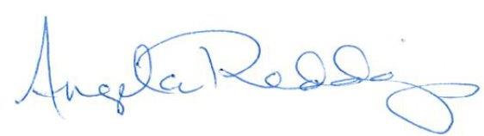
Angela Redding
Director of Recreation

Community Knowledge Campus Parking Lot Map

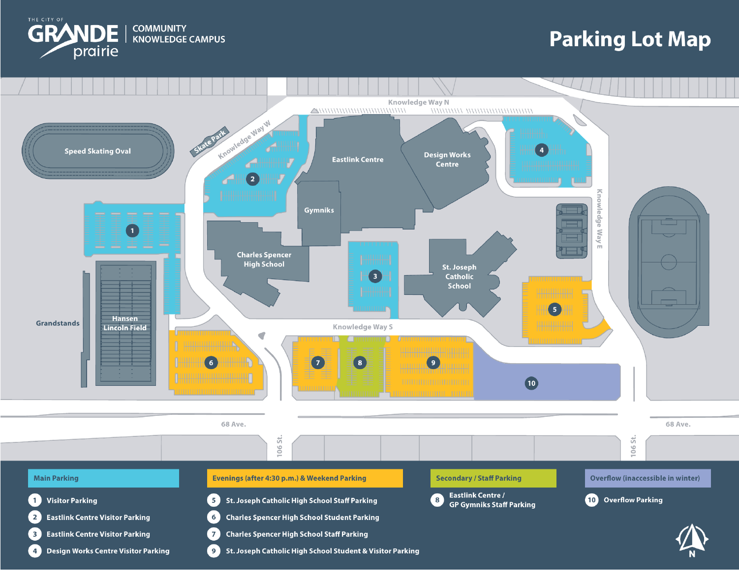

Parking Lot D Best Practices
- Parking Lot D has limited electrical receptacles that share one breaker and can overload easily.
- Please limit electrical use to lights and charging personal devices only.
- Do not use receptacles for RV appliances, heaters, air conditioners, microwaves, refrigerators, or other high-power equipment. Please use battery power or propane for these items.
- If the breaker is overloaded, restoring power may take several hours or until the following day.

